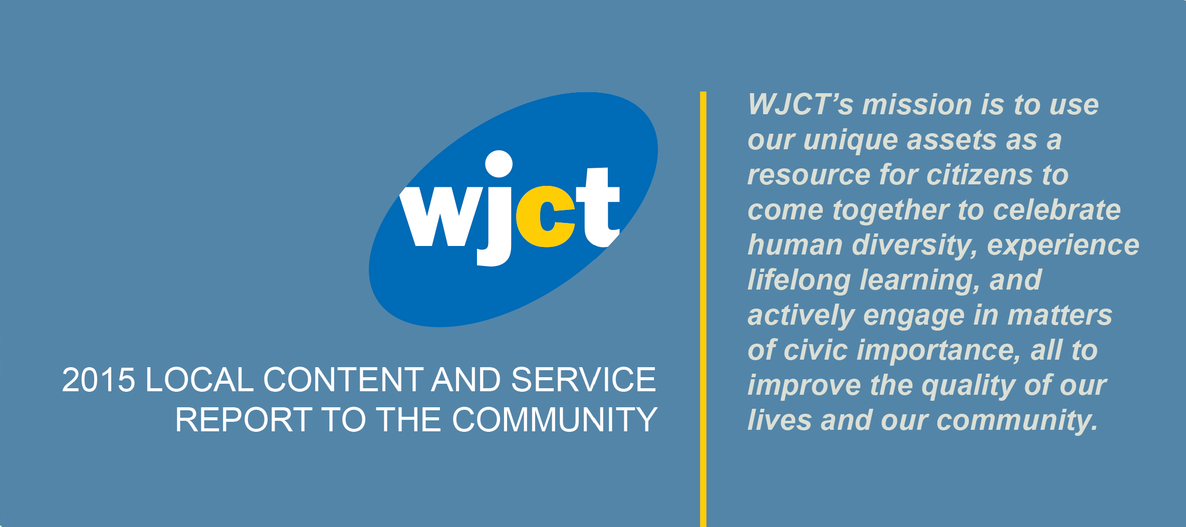

For nearly 60 years, WJCT has provided signature programming and events for the First Coast via unique television, radio, and digital media platforms. In 2015, WJCT used time-tested methods and exciting new strategies to bring services of the highest quality to an increasingly large number of community members. As technology continues to shape the ever-changing media landscape, WJCT remains committed to using its unique assets as a resource for citizens to learn, share, and grow.
— Michael Boylan, WJCT President and CEO

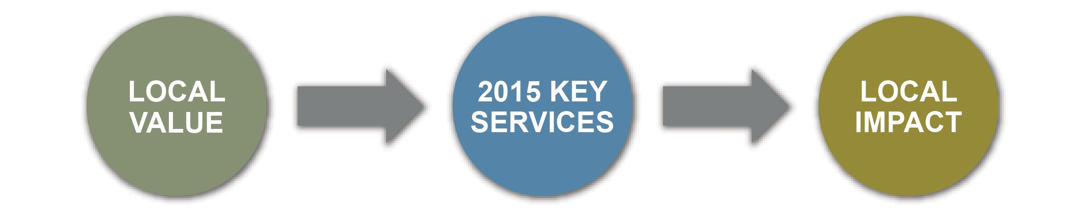

WJCT utilized its unique assets to maximize the value provided to members of the First Coast community.
WJCT unveiled the WJCT Strategic Plan for 2015-2018, a comprehensive blueprint to guide WJCT in advancing its mission on (and beyond) the First Coast.
In 2015, WJCT facilitated several community discussions, including Jacksonville's Mayoral and Sheriff Debates and conversations on matters of public policy such as race relations and mental health.
WJCT continued serving as a community engagement center, making its spacious facilities and office space available to other community-serving organizations.

In 2015, WJCT localized national content and launched initiatives that showcased the First Coast to a national audience.
- Launched the WJCT App, a free service that allows viewers and listeners to access their favorite content "any time, anywhere."
- Created Relax Radio, a new HD radio station featuring the classic songs that baby boomers grew up with and other modern easy listening favorites.

- Listened along with the nation as Melissa Ross, host of WJCT's First Coast Connect, spent three days in Washington D.C. as guest host of The Diane Rehm Show.

WJCT continued its commitment to serving the community with the launch of new local series and events that inform, educate, and empower citizens.
- WJCT introduced Community Thread,
a multimedia experience inviting citizens to join in one big, city-wide conversation about the topics affecting us most.
- WJCT joined the movement with its own Generation Listen program, a new NPR initiative connecting younger listeners to public radio and each other.
- Faith Matters, a quarterly series exploring issues through the lens of faith, premiered on 89.9 WJCT-FM.

-1-
Contents
In the Community, p. 2 Stories of Impact, p. 6 Measuring Impact, p. 8

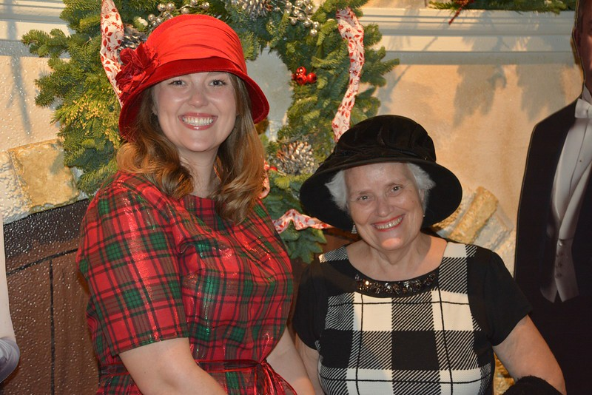IN THE COMMUNITY: LOCAL EVENTS
Downton Abbey Premiere Party. Over 300 Downton Abbey fans from across the First Coast gathered at WJCT Studios for a preview of the sixth and final season of MASTERPIECE's hugely popular series. Attendees were encouraged to dress up for the final year of this fun WJCT tradition, which included food and drinks, photo opportunities and a chance to see the first hour of Downton Abbey's final season before its national premiere.
Chaplains Documentary Premiere. WJCT hosted the First Coast premiere of Chaplains, a two-hour documentary that takes viewers inside the lives of the men and women who provide spiritual and pastoral care to those in need of guidance. WJCT invited several local chaplains to the free public screening, which began with a reception and featured a Q&A session with Chaplains director Martin Doblmeier.
Jacksonville 2015 Mayoral Debate. On March 12, 2015, WJCT Public Broadcasting teamed up with local partners First Coast News and The Florida Times-Union to provide Jacksonville's voters with a comprehensive look at the 2015 mayor's race. The live debate was held at WJCT Studios and simulcast on WJCT Public Television, 89.9 FM and online at WJCT.org.
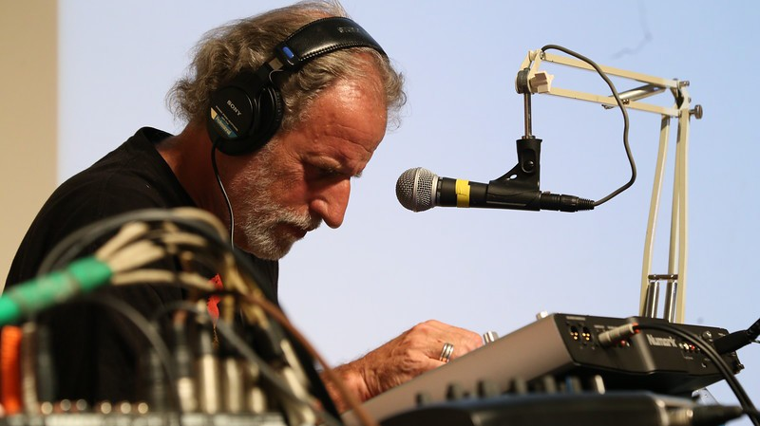Race in the River City. WJCT hosted Race in the River City, a community conversation about issues of race and justice. State of the Re:Union host Al Letson facilitated the evening, which was attended by a diverse group of community members, law enforcement officers and experts on race and society. The event gave many First Coast residents the opportunity to hear the honest perspectives of others in their community.
One Spark 2015. WJCT promoted and participated in One Spark, Jacksonville's arts and innovation festival, for a third consecutive year. WJCT's First Coast Connect on the Go! series gave festival attendees the opportunity to become audience members for one of three One Spark-themed editions of First Coast Connect hosted by Melissa Ross and recorded from the MOCA Jacksonville theater during festival evenings. Sean Birch produced the shows and WJCT Music Director David Luckin attracted guests and kicked things off with an Electro Lounge pre-show.
Swamp Radio. WJCT broadcast special radio encores of the
second season of Swamp Radio, a local stage and radio show that

uses stories, music and interviews to celebrate the many things
which makes Northeast Florida unique.
Generation Listen. In 2015, WJCT became one of the first public broadcasting stations in the nation to start its own Generation Listen program. Generation Listen is a national movement to build a community of young NPR listeners who are curious about the world and passionate about creating a more informed and engaged public. WJCT's Gen Listen group held four events in 2015, including "WJCT Trivia Night" at a local coffee shop and a spooky Halloween "listening party" with sweet treats for attendees. WJCT's Generation Listen Facebook group currently has over 170 members.
Art in the Park. WJCT joined several of Jacksonville's cultural organizations for Art in the Park, a free event for citizens to become aware of and celebrate art on the First Coast. WJCT gave out gift bags with educational resources, held a free drawing for a prize basket and participated in the official Art in the Park scavenger hunt, one of several activities for families in attendance.
-2-
WJCT Music Director David Luckin at One Spark 2015.

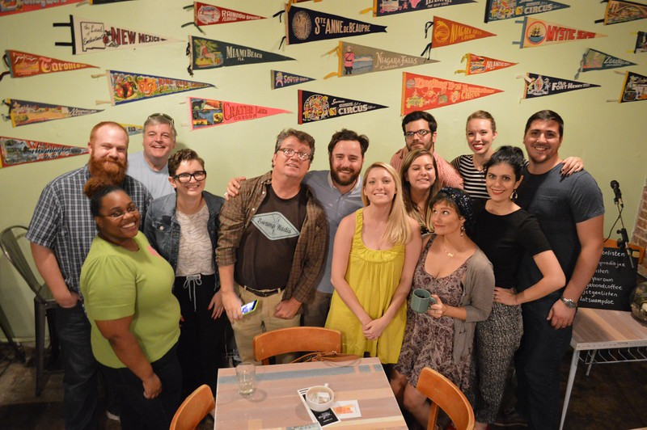
WJCT teams up with local friends Vagabond Coffee and Swamp Radio for a "Gen Listen" event.

ONGOING SERIES, SPECIALS AND SERVICES

The WJCT App. The WJCT App, launched in October 2015, allows public broadcasting fans on and beyond the First Coast to connect with WJCT in a brand new way. The app provides easy access to PBS programs on demand (including PBS Kids programs), WJCT's radio and television schedules, WJCT News and more. Use of the app isn't limited to WJCT's listening and viewing area, which allows First Coast residents to watch their favorite WJCT, NPR and PBS content "anytime, anywhere." The WJCT App is free to download in the Apple App Store and Google Play.
WJCT News. WJCT News is an online news source created to complement the news reports and programming on 89.9 WJCT-FM. WJCT News was redesigned in 2015, making it easier than ever for visitors to find top stories, subscribe to podcasts, listen to WJCT's music programs and discover the best in local, state and national news.
First Coast Connect. WJCT's flagship daily radio program hosted by Melissa Ross, First Coast Connect features local newsmakers, civic and community leaders, arts, activities and more, along with news features and a weekly roundtable of local journalists. Community members join the conversation via phone, email, tweet and Facebook posts. In 2015, First Coast Connect marked its sixth year on air with the free First Coast Connect Podcast on iTunes and Stitcher and by partnering with the Jacksonville Public Library to launch the monthly First Coast Connect Book Club for library and literature lovers.
First Coast Connect "On the Go!". First Coast Connect's tradition of live shows continued in 2015, with broadcasts from One Spark 2015, a Generation W event and the celebration commemorating the 450th anniversary of St. Augustine, the first settlement in the United States.
Electro Lounge. Over ten years after its launch, Electro Lounge continues to offer listeners around the world "music without walls." Host David Luckin organized an event at Lillie's Coffee Bar in Neptune Beach, Florida to kick off WJCT's 2015 Spring Radio Pledge Drive. The free event featured Lillie's signature coffee, delicious desserts and a live Electro Lounge broadcast with performances from local artists.
The Square. The Square is an online venue where locally created art is shared and enjoyed. Every quarter, community members are invited to vote on their favorite original music, paintings, poetry, photography, dance, sculpture and other art mediums submitted by local artists. The top three vote-getting artists are featured on First Coast Connect and in between programming on WJCT Public Television. In 2015, there were 16,654 votes cast (one vote per person) for more than 250 entries.
Policy Matters. Hosted by Rick Mullaney, director of Jacksonville University's Public Policy Institute, this quarterly program examines current public policy issues such as taxes, healthcare and downtown redevelopment.
It's a Wonderful Life. WJCT proudly presented a community theatre radio production of It's a Wonderful Life. The imaginative adaptation of Frank Capra's classic film about dreams, sacrifice and redemption in small town America featured all local voice actors and professional sound effects. Ask Deemable Tech co-host Ray Hollister directed the hour-long production, which aired for 24 hours straight on 89.9 FM from 8 p.m. on Christmas Eve to 8 p.m. on Christmas Day.
-3-

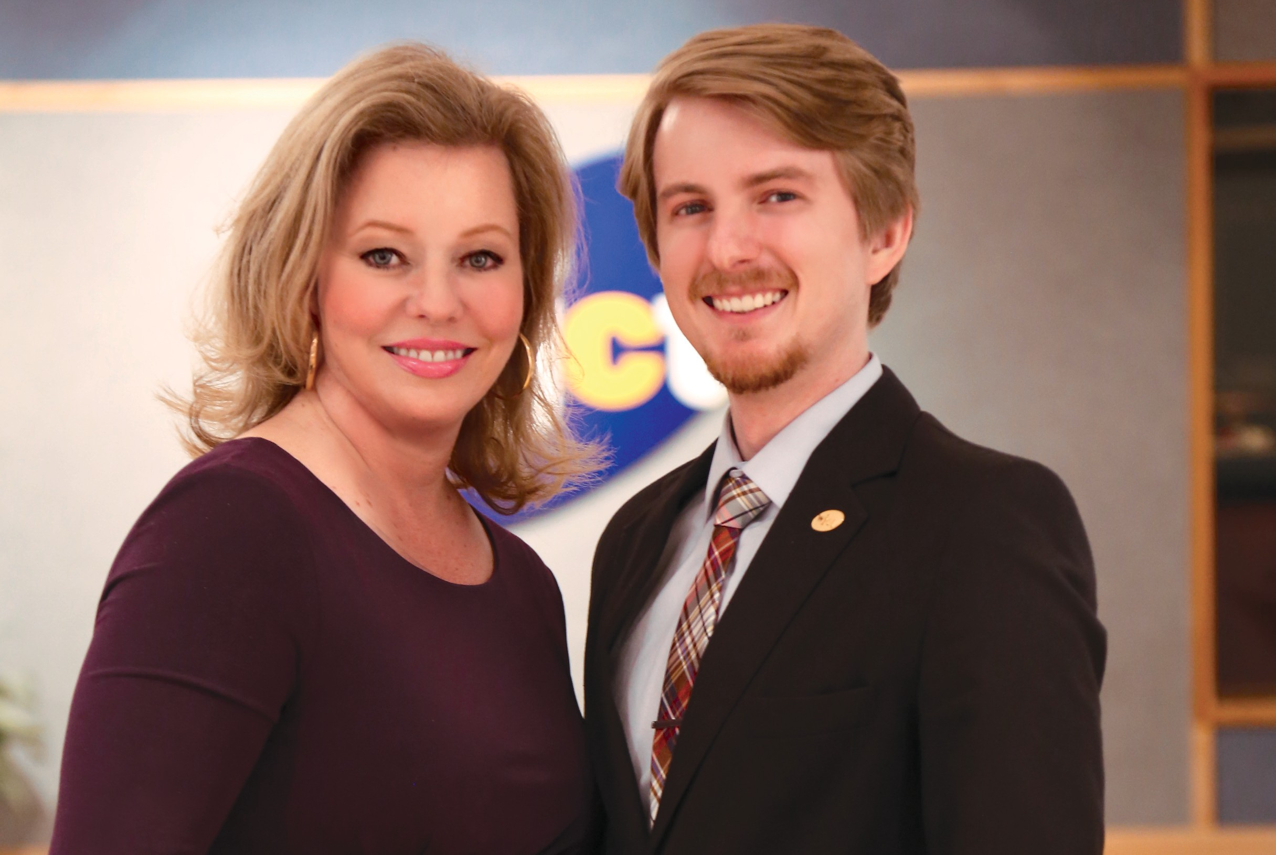
WJCT's award-winning First Coast Connect team: Host Melissa Ross and Producer Sean Birch.

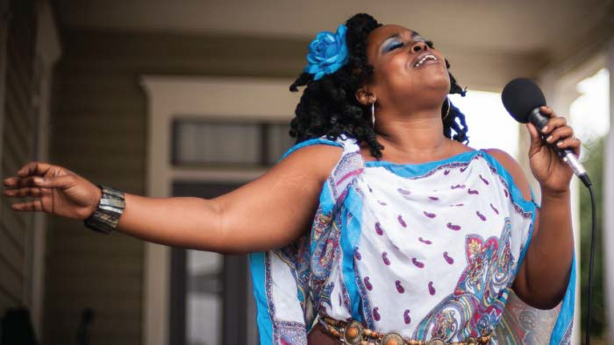
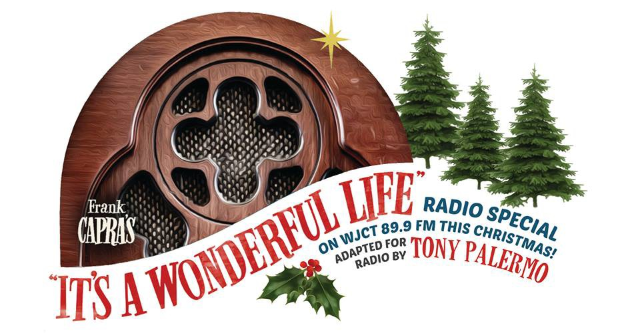Jacksonville native and The Square winner Mama Blue performing her winning song, "Closer to Free."

EDUCATION / EMPOWERMENT
Good For You: Girls' Day Out. In 2015, WJCT and Baptist Health presented their annual women's health conference, now with a new name and new look in its 15th year. Approximately 800 women attended the event, which included informative breakout sessions, personal screenings, door prizes and much more. The day's keynote speakers were comedian/motivational speaker Diana Jordan and Jessie Close, sister of actor Glenn Close. Michaela Bradley served as the event's honorary chair. www.wjct.org/baptist-good-for-you
Stories of Service. For the fourth year in a row, WJCT invited First Coast residents to submit veterans’ names, then recognized the veterans for their service during on-air and online appreciation spots throughout November. The spots provide a moving tribute to local military.
TEACH 2015. In September, WJCT presented its fourth annual TEACH professional development conference for educators. The event featured national keynote speakers, breakout sessions with local and national experts, access to educational resources, opportunities to network, and more.
700 educators from various counties and states attended. wjct.org/teach
Faith Matters. Hosted by the OneJax Institute's Nancy Broner and Kyle Reese, WJCT's new quarterly series Faith Matters explores today's most pressing issues through the lens of faith. The first episode discussed the role of forgiveness in learning how to heal and understand after tragedies.
Ask Deemable Tech. Ask Deemable Tech features tech gurus Ray Hollister and Tom Braun as they answer listener's questions about computers, smartphones, the internet and more.
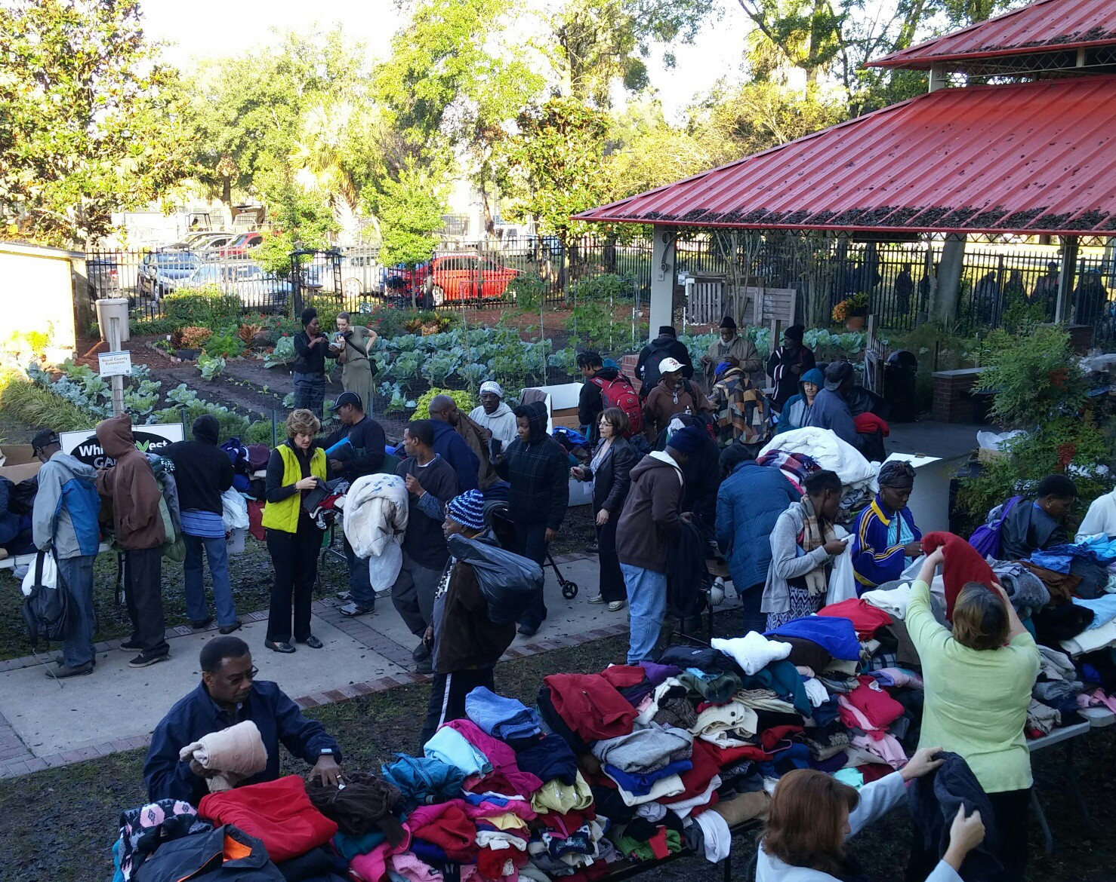Mister Rogers’ Neighborhood Sweater Drive. WJCT partnered with VyStar Credit Union and the Duval County Public School PTA to present the 13th annual Mister Rogers Neighborhood Sweater Drive, honoring the late Fred Rogers by collecting over 15,000 sweaters, jackets, blankets and socks.
The items were generously contributed by First Coast community members, including 500 students from participating schools. Items were distributed to Clara White Mission and other First Coast nonprofits serving neighbors.
Next Avenue. This website offers adults in their 50s and beyond the knowledge they need to navigate their new stage of life! It's the place where grown-ups keep growing. wjct.org/nextavenue
WJCT Radio Reading Service. WJCT's RRS empowers visually- impaired and print challenged community members by broadcasting commercial-free readings of local and national

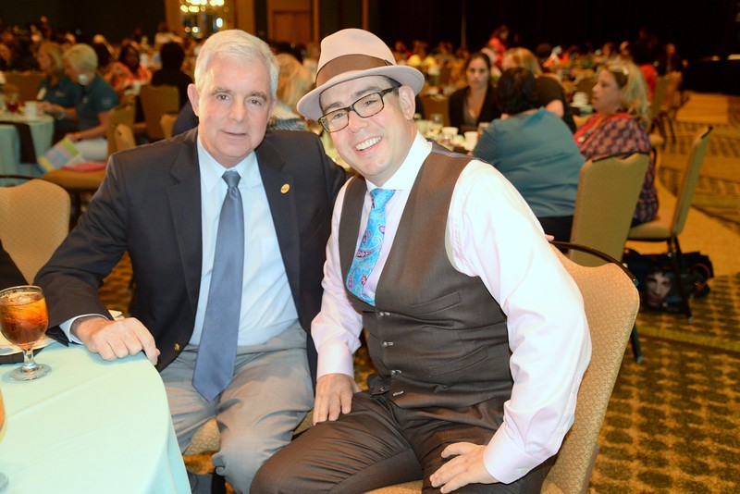
WJCT President and CEO Michael Boylan with Drew Dudley, TEACH 2015 Keynote Speaker

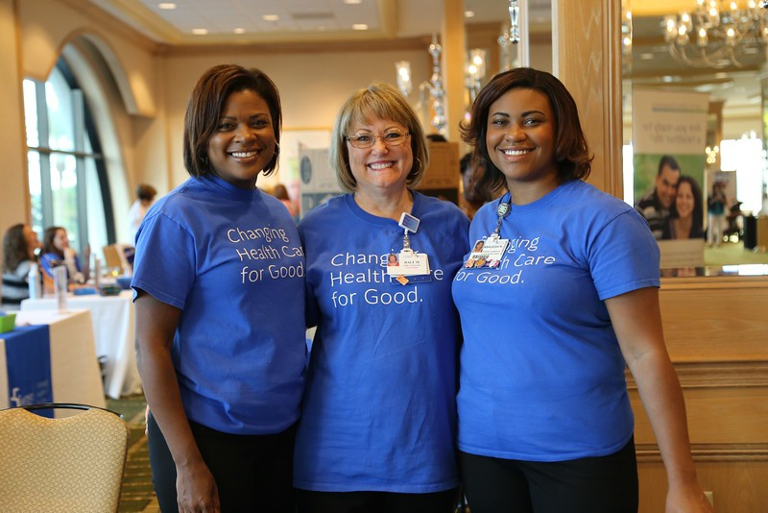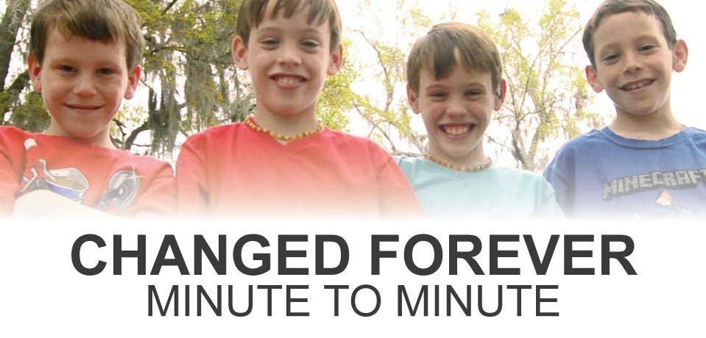newspapers, magazines, and books 24 hours a day, 7 days a week. In its 22nd year, RRS is powered by its tireless volunteers who provide the only service of its kind in Northeast Florida.
Changed Forever: Minute to Minute. Created by WJCT as a local companion piece to Cancer: The Emperor of All Maladies, Changed Forever tells the story of the Auclairs, a family dealing with child cancer. When one of their eight-year-old quad boys was diagnosed at birth, the Auclairs joined a population of families that experience daily challenges. A story of fear, hope and remission, Changed Forever allowed the Auclairs to give advice to other families beginning similar journeys. Viewers were directed to a variety of child cancer support resources that were offered on WJCT's website during and after the broadcast.
-4-
The 13th annual Mister Rogers Neighborhood Sweater Drive.

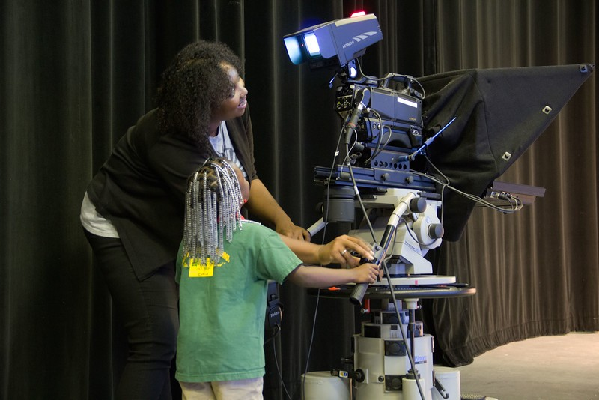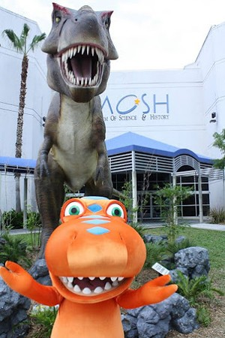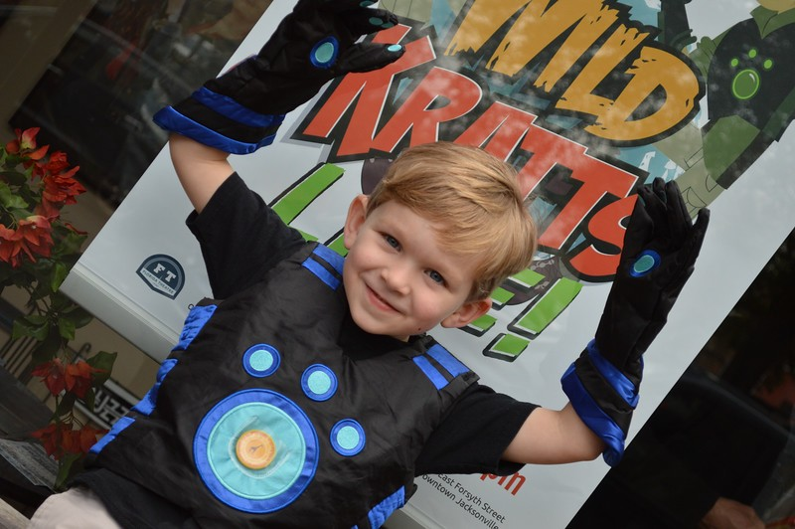
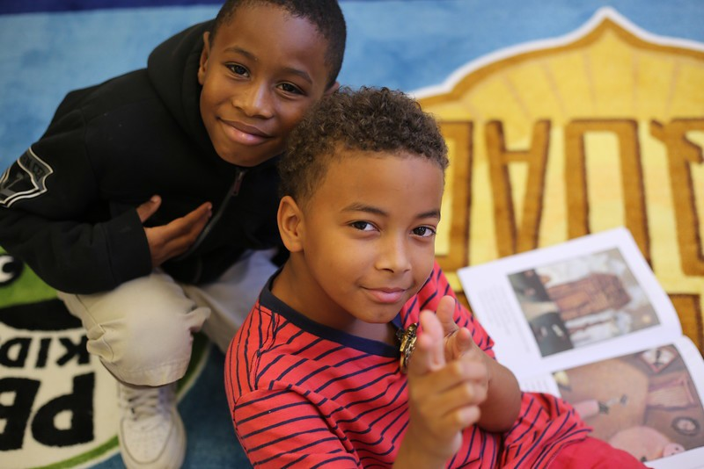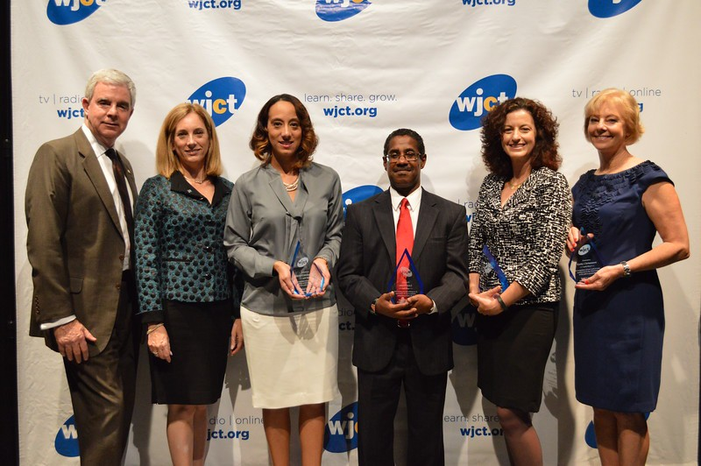WJCT's 'Odd Squad' Summer Camps American Graduate Champions 2015

WJCT KIDS

American Graduate Day 2015. WJCT joined in a full-day broadcast and outreach event dedicated to helping young people across the country stay on the path to graduation. In addition to multi-day workshops held for Duval County Public School teachers, WJCT hosted the 2015 American Graduate Champions Banquet to honor five Northeast Florida education champions for their efforts in making sure everyone graduates from high school.
PBS Kids Writers Contest. WJCT participated in the 14th annual PBS Kids Writers Contest, a national initiative designed to promote the advancement of children’s reading skills through hands-on, active learning. WJCT encourages K-3 students across the First Coast to tap into their inner author by writing and creating original stories. Local winners are entered into the national contest and have their stories featured online.
Odd Squad Summer Camps. Based on PBS's new Daytime Emmy Award-winning series, WJCT's five-day long 'Odd Squad: Be the Agent' summer camps allowed 144 children ages six through eight to step into the shoes of Odd Squad agents. The "agents" engaged in interactive content, games and crafts that challenged them to apply specific math skills from the Odd Squad series to solve a series of odd cases. Take-home activities reinforced what the kids learned each day.
Wild Kratts LIVE! 2015. On February 16th, 2015, WJCT teamed up with The Florida Theatre to bring the animated adventures of brothers Martin and Chris Kratt to Jacksonville. An animated series turned "real life" in classic Kratt brothers style, Wild Kratts: To the Creature Rescue was filled with hilarious pitfalls, amazing animal 'wow facts' and tons of giggles for parents and kids in Creature Power Suits alike. A total of 3,800 guests attended the two showings.
PBS LearningMedia. Throughout 2015, WJCT promoted PBS LearningMedia, America's #1 Educational Media Brand. Events like the TEACH Conference 2015 gave WJCT a platform to demonstrate to hundreds of parents, educators and other stakeholders across the First Coast the many innovative, standards-aligned digital resources, compelling student experiences and professional development opportunities available at florida.pbslearningmedia.org.

WJCT Kids Club. The WJCT Kids Club is where fun begins for First Coast kids up to the age of 11! The club's more than 1,200 members receive information about special events, have their birthday recognized on-air and are entered into drawings for special prizes. In 2015, WJCT Kids Club activities included a Buddy the Dinosaur Meet and Greet at the MOSH Jacksonville Museum of Science and History (pictured above). New members are signing up for the kids club daily.

-5-

RELAX RADIO: THE MUSIC OF YOUR LIFE...
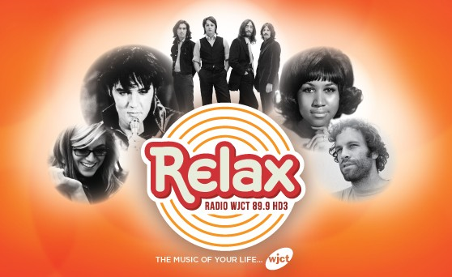When Jacksonville's premier easy listening radio station of half a century went off the air in late 2014, listeners contacted WJCT in hopes that something could be done to fill the void left in the community. In response to these requests, WJCT created Relax Radio, a brand new HD radio station for the First Coast featuring more than 2,000 songs that span the spectrum of time from Bing Crosby to Michael Bublé. Instrumental to the massive task were WJCT Engineer Alan Rhodes, who built the automation infrastructure for the station, and WJCT Music Director David Luckin, who led the project and curated the music of Relax from his own extensive music collection. Relax blends oldies, light jazz, orchestral pop, music from the Great American Songbook and new favorites in a fresh way that appeals to baby boomers and younger listeners alike. The 24 hour music service also features NPR News updates and weather information at the top of every hour.

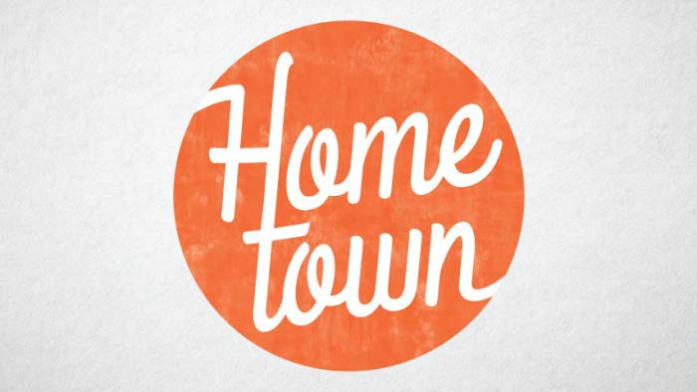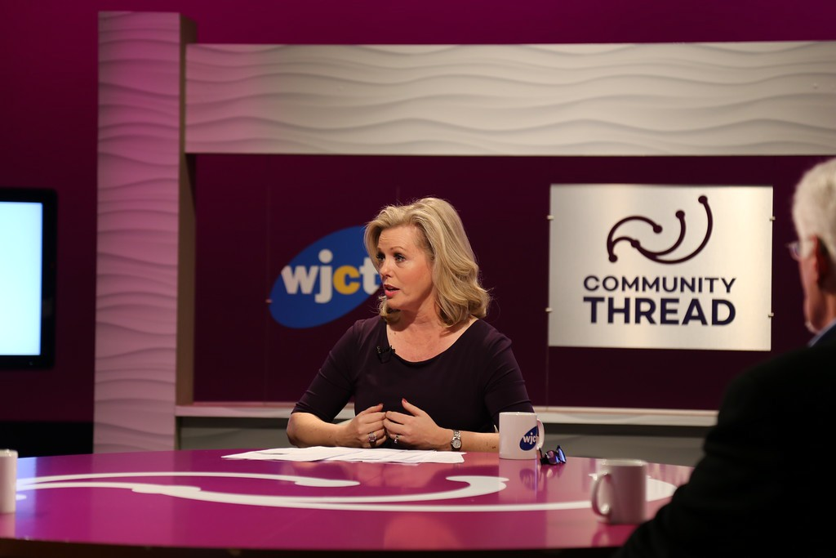'COMMUNITY THREAD' SERIES LAUNCHES

WJCT's tradition of hosting interactive community forums designed to address critical challenges facing the First Coast continues with the launch of Community Thread. Expanding on WJCT's previous First Coast Forum concept, Community Thread is a quarterly, hour-long television program hosted by Melissa Ross and ongoing series of radio stories by the WJCT News Team that respond directly to audience-submitted questions. A new set was designed from recycled materials to better facilitate conversation between panelists. Filmed before a live studio audience, Community Thread airs one week after taping to allow time for editing and more engaging, sophisticated on-air elements. Most importantly, additional online and radio content ensure that important conversations continue beyond the hour-long broadcast.

NEW LOOK, NEW HOST FOR 'HOMETOWN'
In 2015, WJCT created a new design for Hometown, its monthly television series that tells the stories of the people, places and events that make the First Coast a great place to live. Hometown's new look and the addition of local actor Daniel Austin as host brought a fresh look and feel to reflect the evolution of the series, which completed its fourth season in 2015. Each Hometown episode features at least one local artist, arts organization or venue. WJCT President and CEO Michael Boylan sees the series as a way to inspire pride in citizens of the First Coast. "Hometown is part of WJCT's larger vision to help viewers feel more connected to each other and to all of the incredible people and events that make our community special.
Telling these stories is part of our commitment to promoting civic engagement and lifelong learning."

-6-

WJCT OnDemand
Over a dozen of WJCT's locally produced radio and television series are available OnDemand at wjct.org/ondemand!

THE WJCT STRATEGIC PLAN 2015-2018

WJCT's Board of Trustees, Community Advisory Board, staff members and other key stakeholders collaborated to develop the WJCT Strategic Plan, a blueprint to guide WJCT in advancing both its mission and the well-being of the citizens it serves. The plan maps out strategies and tactics to successfully guide WJCT from 2015, when the plan was first approved, to 2018, when WJCT will celebrate its 60th anniversary of serving the First Coast.
The many strategies and tactics that make up WJCT's Strategic Plan for 2015-2018 were built around the four pillars that comprise the fundamental principles of WJCT: positioning (being better known and supported as an indispensable resource to the community), content generation (including the localization of national content), financial well-being and organizational effectiveness.
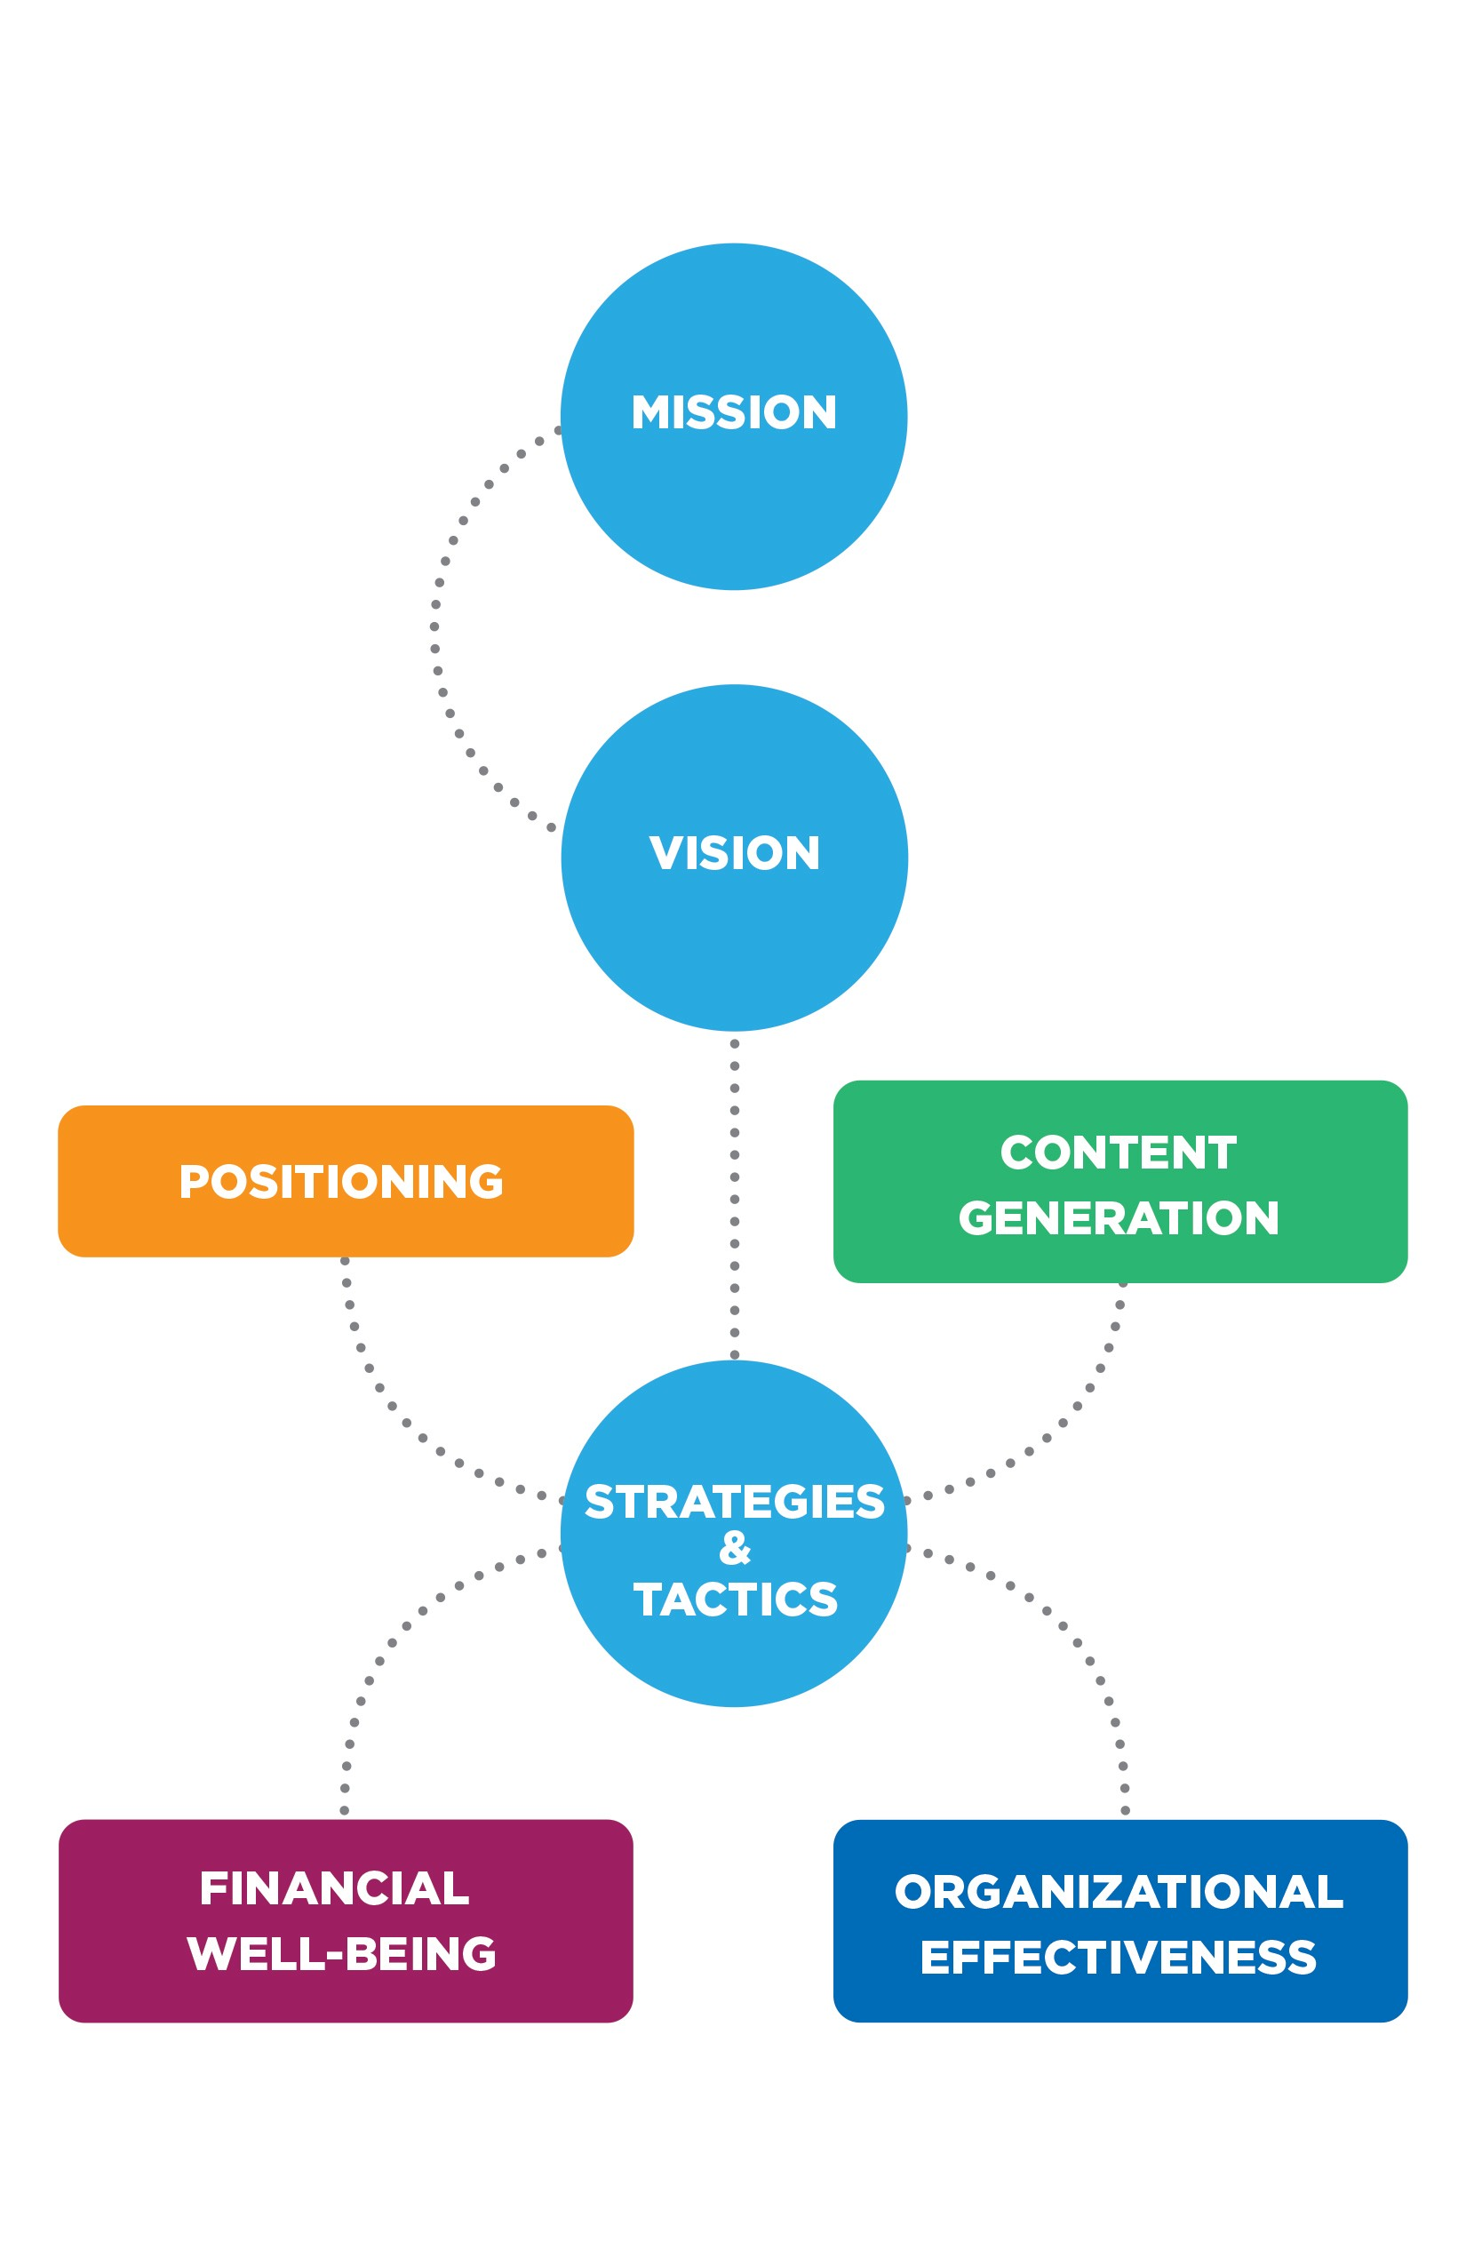In keeping with the timeline for this strategic plan, WJCT has already begun and successfully completed several milestones, including the launch of the WJCT App and Generation Listen. Through the implementation of this plan, WJCT will continue achieving its vision to connect citizens to content, share ideas and set the standard through which the community learns and grows.

THE DIGITAL CONVERGENCE ALLIANCE NETWORK OPERATIONS CENTER
The Digital Convergence Alliance, a not-for-profit corporation, was created to develop and implement initiatives to foster increased efficiencies and create new revenue opportunities for DCA member stations. The DCA Network Operations Center is the first of these initiatives, creating a centralized master control operation system to minimize infrastructure-related challenges, particularly the need to replace or upgrade outdated equipment.
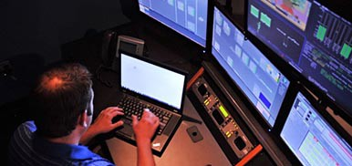The 2014 unveiling of the Digital Convergence Alliance Network Operations Center (DCA-NOC) marked the culmination of a multi-station, four-year endeavor spearheaded by WJCT. Six public television stations from Florida partnered with WPBA (Atlanta), WTTW (Chicago), WILL (Champaign), MPTV (Milwaukee), and KERA (Dallas) to create the Digital Convergence Alliance (DCA).

WJCT FOUNDATIONAL PILLARS, STRATEGIES & TACTICS

A grant from the Corporation for Public Broadcasting (CPB) to the DCA provided the opportunity to bring this vision to life. JCT Services (in partnership with tw telecom, the network provider, and Cologix, the facility housing the NOC) a subsidiary of WJCT, Inc., was awarded the management contract for the build out and operation of the NOC.
Representatives from most DCA member stations and many other VIPs attended an open house event to celebrate the launch of the NOC. Today, over 16 million households across the country are being served from a single building located in Jacksonville, Florida.

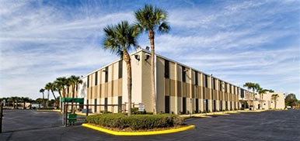
Jacksonville's Cologix, a colocation and disaster recovery provider, houses the DCA's Network Operations Center.

-7-

WJCT measures its impact by the number of community members engaged, the recognition of peers and colleagues, and the words of those impacted by WJCT's service to the community.

The Numbers* ...

57 hours of educational children's programming per week

8,760 hours of Radio Reading Service broadcasts for visually impaired and print challenged community members

10,099 guests attendeed WJCT events

265,000 households viewed WJCT Public Television

916,266 people reached by WJCT
via virtual/online media each quarter
* Data from Cultural Service Grant Program Reports
The Word on the Street …
A small sample of the many written comments WJCT received in 2015.
“Such a wealth of entertainment coming from WJCT! Thank you so much for the quality programming you provide."
—Louise R., WJCT Listener/Viewer

“This was my first TEACH Conference, and it was so much more than I expected. I greatly enjoyed this day. It was not time wasted... I'm truly better for attending.”
—TEACH Conference 2015 Attendee

"I just wanted to thank you guys for putting together this [Generation Listen] event tonight. You did an awesome job curating the stories and I'd like to go back and listen to some of them again. Great job to all involved!"
—Kelly Cho, Generation Listen Event Attendee

“It’s the radio station I was always looking for and never found before now. I don’t think there’s anywhere else you can go and find that assortment of music in one radio station. It truly is the music of my life.”
—Harry Reagan, Jacksonville Resident & Relax Radio Listener

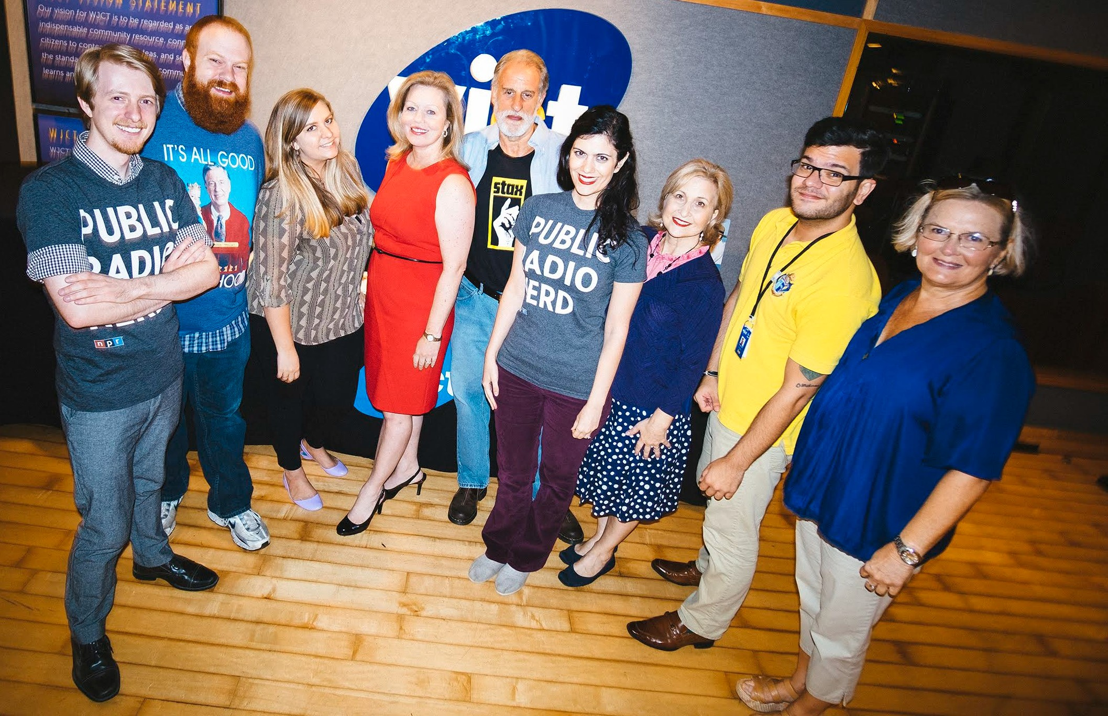WJCT Awards ...
State of the Re:Union, the public radio program created and hosted by Al Letson and presented by WJCT, won its third consecutive Edward R. Murrow award for its episode "Trans Families." The show also received a prestigious George Foster Peabody Award for its entire 2014 season.
WJCT's First Coast Connect received its fourth national PRNDI award, capturing first place in the "Call-In Program, Division B- Medium Staff" category for its episode on the Michael Dunn verdict.
First Coast Connect host Melissa Ross was voted Best Radio Personality/Host by readers in the Florida-Times Union and
Jacksonville.com's inaugural Bold City Best contest. Photo Credit: Folio Weekly Magazine/Dennis Ho

The U.S. Green Building Council North Florida Nonprofit Chapter named WJCT's Melissa Ross its 2015 Green Media Award recipient for her coverage of environmental issues in northeast Florida during First Coast Connect's recurring "Going Green" segment.
WJCT President & CEO Michael Boylan was selected by local nonprofit OneJax to receive a 2016 Silver Medallion Award in recognition of his outstanding dedication & community service. OneJax promotes diversity as the foundation for a strong community.
WJCT received three awards in Folio Weekly’s Best of Jax 2015 readers’ poll—Best Radio Show (First Coast Connect), Best Radio Personality (Melissa Ross) and Best Radio Station.
The WJCT News Team received the Florida Associated Press Broadcasters award for Best Radio Newscast up to Five Minutes in Length (Large Market).

“In 2015, WJCT continued its mission of serving the First Coast community. That success was only achieved through the support and tireless efforts of our WJCT family of viewers, listeners, board members, staff members, supporters, fans and followers. Thank you for making us possible.”
—Michael Boylan, WJCT President and CEO

-8-

